Appointment Manager with Time Zone API integrated

Documentation v1.0

Laura-Gabriela Haraba

Group 1078

1. Design User Interface
   1. 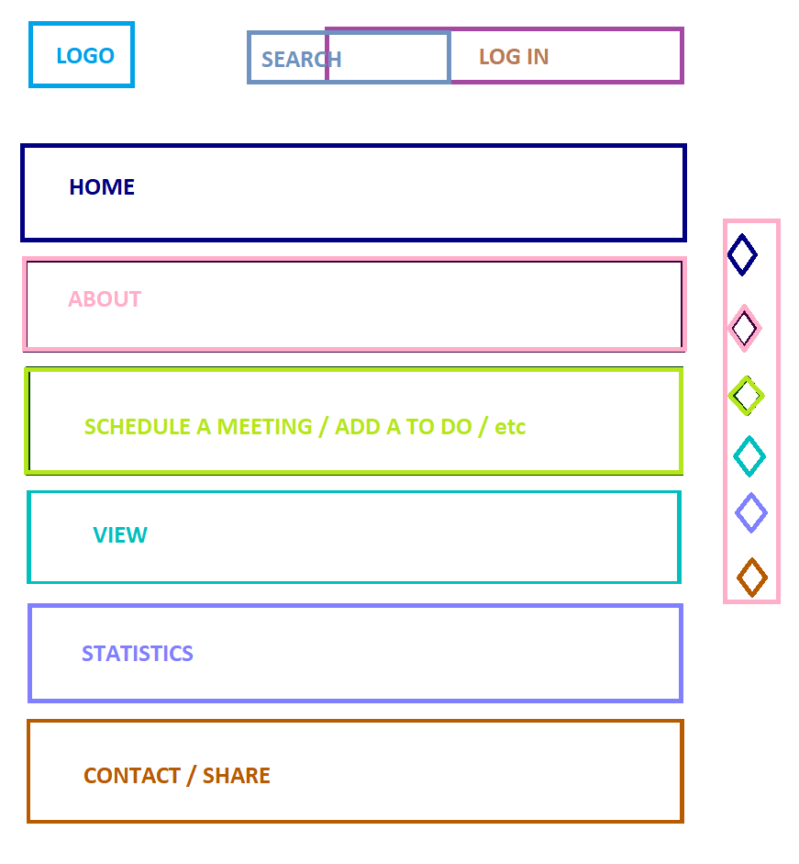
   2. This single page application is going to look like Google Calendar or Outlook Calendar. I can set a limit for view to ‘month’ only and when I press on a day from that specific month the appointments from that day to pop-out (or to show-up through a drop-down menu). The Time Zone API will be used, for example, to display the appointments based on a specific time zone. The form will allow the user to select multiple time zones in order to schedule meetings with people from USA, let’s say. External Time Zone API
2. Identify Components:
   1. Calendar
      1. Free National Days
      2. Events
         1. Time, location, recurrence, description, invite people, notifications, availability, visibility
      3. Share Calendar option
      4. Make new calendar option
      5. Address Book
      6. Reminders
      7. Recommendation
      8. Agenda
         1. To Do/ in Progress/ Done/ FYI / Important/ CheckList
3. Identify API Calls:
   1. timeZoneName
   2. timeZoneId
   3. status
   4. ADD / EVENT
   5. CANGE / EVENT
4. Define User Actions:
   1. View Calendar
   2. Search Event
   3. Add Event
   4. Change Time
   5. Add Participants
   6. Add Addresses
   7. Cancel event
   8. Set priority
   9. Categorize
   10. End month report

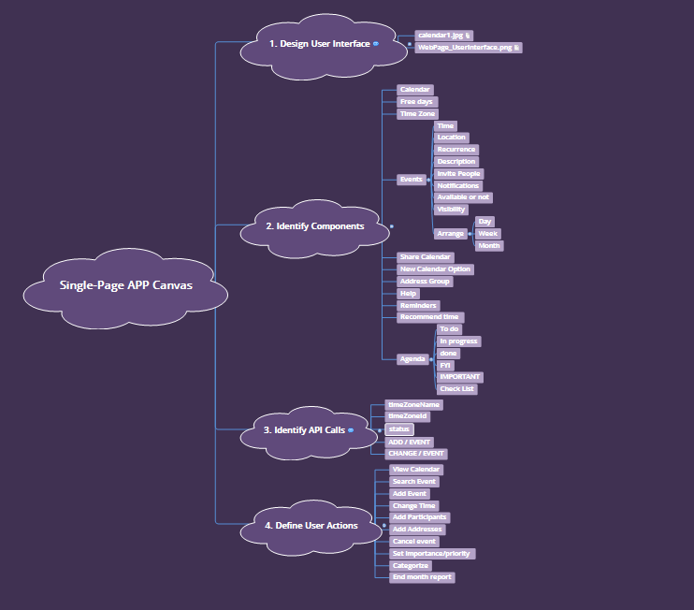

As we talked at the seminar, the SPA is not going to focus on all those points, but it will have, at least, the main actions for a simple user (for example, a doctor who wants to schedule his work).